**BLZ depletion experiment -FEMALES**  
sequencing date: 30.04.2021

Sequencing platform: Novaseq

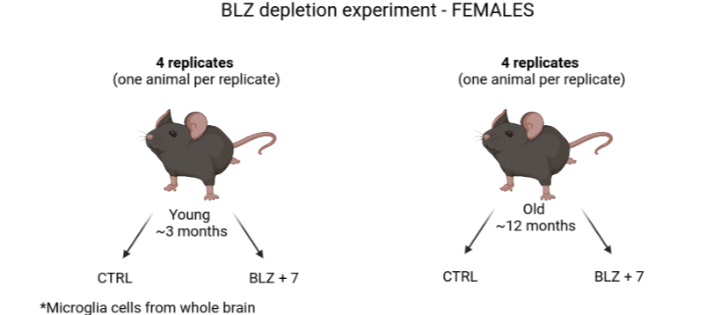

|  |  |  |  |  |
| --- | --- | --- | --- | --- |
| **Samples:** | | | | |
| **Rep1** | CTRL Y1 (Ab #1) | CTRL O1 (Ab #2) | BLZ+7 Y1 (Ab #3) | BLZ+7 O1 (Ab #4) |
| **Rep2** | CTRL Y2 (Ab #1) | CTRL O2 (Ab #2) | BLZ+7 Y2 (Ab #3) | BLZ+7 O2 (Ab #4) |
| **Rep3** | CTRL Y3 (Ab #1) | CTRL O3 (Ab #2) | BLZ+7 Y3 (Ab #3) | BLZ+7 O3 (Ab #4) |
| **Rep4** | CTRL Y4 (Ab #1) | CTRL O4 (Ab #2) | BLZ+7 Y4 (Ab #3) | BLZ+7 O4 (Ab #4) |
| **Libraries (Sample from each condition hashed and pooled in one library)** | | | | |
| **RNA** | Rep1 (Index D1) | Rep2 (Index D2) | Rep3 (+ CTRL O4)* (Index D3) | Rep4 (- CTRL O4)*  (Index D4) |
| **protein** | Rep1 (Index D5) | Rep2 (Index D6) | Rep3 (+ CTRL O4)*  (Index D5) | Rep4 (- CTRL O4)*  (Index D4) |
| *Sample CTRL O4 was mistakenly loaded together with Rep3 samples. Thus, the resulting library – Rep3, consists of two samples tagged with same hash antibody – CTRL O3 and CTRL O4, that will be indistinguishable and thus will form one pooled replicate. | | | | |

**List of stained surface proteins:**

|  |  |  |  |
| --- | --- | --- | --- |
| Antibody | Barcode | Source | Type |
| TotalSeq™-B0301 anti-mouse Hashtag 1 Antibody **(Ab #1)** | ACCCACCAGTAAGAC | Biolegend | HTO |
| TotalSeq™-B0302 anti-mouse Hashtag 2 Antibody **(Ab #2)** | GGTCGAGAGCATTCA | Biolegend | HTO |
| TotalSeq™-A0303 anti-mouse Hashtag 3 Antibody **(Ab #3)** | CTTGCCGCATGTCAT | Biolegend | HTO |
| TotalSeq™-B0304 anti-mouse Hashtag 4 Antibody **(Ab #4)** | AAAGCATTCTTCACG | Biolegend | HTO |

**Description:**

A microglia depleting agent BLZ945 was administered for 3 weeks along with peanut butter vehicle. Controls were given peanut butter only (CTRL). Next, microglia were allowed to recover for a period of 7 days (BLZ +7 )

Whole brains (excluding cerebellum) were dissected and dissociated. Next, microglia cells were FACS sorted prior to 10x experiment.

We targeted 11 000 cells per library, which corresponds to 2 750 cells per sample.

Number of microglia cells isolated from BLZ+7 O4 was very low, which may indicate poor recovery rate in this animal. Sill, we were able to load 3 000 cells for this sample.